Dear Mark,

I just found this letter from you stuck in my files!
Don't know how I missed it!
I'll write and discuss it's content as soon as possible, but it may be a few weeks!

Sincerely, your friend James . . .
=============================================================
Dr. James A. Gray, Sr.
"Prayerful Solutions!"
Christian Counseling Services
1335 North Caddy Lane
Wichita, Kansas 67212
(316) 641-7029
====================
----- Original Message -----

From: Mckay, Mark
To: Dr. James A. Gray, Sr.
Sent: Tuesday, September 26, 2006 8:57 PM
Subject: RE: Edwin Vincent GrayTimeLine.doc

Dear James,

I have still been pondering your historical revelations. I still have a hard time understanding how your father appears to have accomplished so much in such a short period of time. All I can come up with is that he was working on this project secretly from 1964 to 1969 as money and time would allow.

But why so much secrecy? If it was just intended to be a novel motor then no big deal. This points to the idea that he had the foundation for a "Free energy" device in 1958 and knew it. He hired Mr. Cole to put his more advanced ideas on paper. Most likely there were some technical issue(s) that hindered the actual construction progress. Or maybe the financial upheaval was the real impediment. Whatever it was it was resolved in that 1964 to 1969 time frame. As soon as he could demonstrate the Black Box power inverter he was off and running. According to documents that Peter Lindemann has this device could yield COP's of 81 (Coefficient of Performance). The demonstration for this device is pretty effective. A small motor cycle wet cell powers 1400 watts of load (light bulbs, motors, Electronics) for about 8 hours. I certainly would have invested if I were there.

This still doesn't explain where he got the inspiration from in the first place, or why it never made it to market. We can make some pretty good guesses about why the technology didn't get to market, but we may never know where the original came from. Where ever it was, there is a strong chance that he knew what it was when he saw it and was willing to pay money to document it.

There are some questions I have about Renata that might help explain some of the events in this time period.

As you mentioned, there appears to be a considerable age difference between your father and Rene. In the 1973 "Inventor of the Year" photo your father was about 48. She doesn't appear to be much older than 30. Do you know what the actual age difference was?

Any idea as to how they met? Was she an employee? Perhaps a waitress at the local sandwich shop? I'm sure their meeting is a story in itself. It is rare that couples are established with that kind of age difference. Of course, your probably know far more than I on that issue because of your business background.

Is there a possibility that your father disclosed his successful research to her and that she saw $$$$ with a bright future. So much so that Cupid's Arrows just happened to be so much more effective?

It has been said that Rene's father was Fritz Lens and your fathers mechanical assistant. Is this true that you know of? It would seem like an in house thing to do to hire the wife's father to help keep sensitive matters in the family.

Do you know what Rene's full maiden name was? Is she still around? Did she have a previous marriage prior to your father that you know of?

Your father died in the company of Dorothy. This implies that he and Rene split company at some time in the past. Do you know when and where this might have been and what the circumstances were? Perhaps her dreams did not blossom the way she thought they should.

IF their separation was hostile then the decline of the technology could have been largely a result of ex-marital warfare. She would have wanted half of the value of his accomplishments, since she was their since the beginning and it would have been hard to claim separate estate assets. He would have had to play the role of the impoverished inventor and hide his assets where he could. This would have complicated his quest for manufacturing a single production run. Since she was a business insider she probably knew what the game plan was, before any break up took place. If the relationship went South before the big payoff then I can see how the business plan could have been altered big time.

Maybe dark clouds were forming in the relationship in the 1976-1978 time frame, but didn't actually result in physical separation for years after that. A love gone cold could have been even more devastating than the loss of two primary investors. What could have made matters worse would be that she was also a business partner. If she had the inclination she could have wrecked havoc to his administration process, bank accounts, contacts, bills payable, contracts, technical records, licenses, on and on. I don't know if this happened, but it could have - the potential was certainly there.

There are good reasons that the common wisdom states "Don't get your Honey where you make your Money"

Attached are a few more of your father's articles from 1973 to add to your collection if you don't already have them.

Thanks again for sharing the Truth. Some further comments are below.

Mark

----- Original Message -----

From: Mckay, Mark
To: Dr. James A. Gray, Sr.
Sent: Tuesday, October 31, 2006 6:28 PM
Subject: RE: Edwin Vincent GrayTimeLine.doc

Dear James,

No rush. I've been keeping quite busy in exploring another avenue of research possibilities. I thought I would just share with you some of the work I've been doing so that you can see that some progress is being made.

Mark

Hi Mark,

As I briefed all that enclosed, I am amazed at my father's geniouswhen it came to creativity!
I only wish his penchant for women hadn't distanced him from his first family, so much would
have been different! As I read and re-read these article on his inventions, of which I try so
diligently to understand . . . but to bot much avail! Why is it that brilliant people such as he was
have so much difficulty in interpersonal relationships?!

It is my sincere hope that someone like yourself may unlock his secrets and share them with an
over-due world of such scientific needs! Thank you for continuing to share and explain what you
have researched. It is/has been very stirring!

Sincerely, James

PS: For some reason or another, April is unreachable by e-mail for our family. Seems she has
either blocked us or generated another e-mail address and desires not to share it. Does she
respond to you? Just curious.

Tue 11/7/2006 1:54 PM

Blessings family and friends . . . in Jesus' name!

Today (Tuesday), after my third trip to the Urologist' office, here's the report:

Out of 19 biopsies of my prostate-gland, one quadrant had some unidentifiable cells. So, they have been sent to a research facility for determination. All other regions were benign!

Linda and I asked if what was being said is: are they cancer cells to be confirmed, or are they cells to identified only? We were told that there were just a few cells that needed to be identified
for completion of diagnosis. Thus, they could range from other forms of infection, inflammation, certain types of "itisis" or cancer. In the event they are cancer, they will discern which type it is.

Whatever these cells are, we'll know what and ho to deal with them then. It'll take one to two weeks for the final results

Well, we know that all things are in our Lord's Hands and in His hands is healing power, and all "good" things come to us through and by our Heavenly Father! Amen!

Let us continue to pray for a good final report in Jesus' name . . . Amen!

Dr. James A. Gray, Sr.

----- Original Message -----

From: Mckay, Mark
To: Dr. James A. Gray, Sr.
Sent: Friday, November 17, 2006 7:18 PM
Subject: EV Gray Historical REsearch

Dear James,

I've made contact with a Mr. Joe Gordon of Grand Prairie, TX. He is an attorney who is in the oil drilling and exploration business. He claims to have worked with your father from 1985 till his death. Perhaps you know him? I talked with him for an hour and realized that he was the sole source of the Dr. Papov connection.

According to Mr. Gordon, your father told him that it was Dr. Papov who introduced him to this technology. The rest of the story claims that this happened in Florida while he was working on a secret NASA project. I know this is not correct but I was not going to argue the issue with Mr. Gordon at this time. What is interesting is that Mr. Gordon claims that this took place in 1969. John Bedini has discovered that a Dr. Alexi Papov does exist and was a physicist who did research with electron flow in spark gaps. I don't know when or where he did his work or if there is a real connection to your father. Its just as likely that his name was pulled from a technical magazine.

What this establishes is that Mr. Gordon is the source of this particular story about your father's history, which he considers to be the truth as it was told to him. Mr. Gordon worked with Ken Hawkins and Norm Wooten to recover the EMA4 and EMA5 motors in 2000. Mr. Gordon told them the story as best he knew it. Norm went on to give the 2001 Keeley Conference lecture and write the internet article. So now this partially fabricated story has almost become history.

Mr. Gordon claims that he and your father merged their respective companies (Ztech and Western States Oil) in about 1986. They leased a building in Grand Prairie, TX and used this as a base of operations for a few years. Mr. Gordon has a promotional video of the work your father had developed up till that time. I shall forward you a copy when I receive one.

Apparently a bank account was set up in the Cayman Islands and another individual was hired on commission to sell stock in this newly merged company - off shore. He was actually selling stock in the US where it was not listed with the SEC. According to the story about $50 million in stock was sold. Of course this broker took his healthy commission (and maybe more) and moved (or escaped)to Israel.

According to Ken Hawkins, Dorothy went to the Cayman Islands to withdraw the money but was put in jail. Apparently there was some stock fraud investigation going on but no one would pay to have her extradited back to the US. She was some how released and most likely didn't try that again. The story goes that the bank swallowed all the remaining money just like the Swiss banks took all the money of the Holocaust victims. So this is where the story about all the millions comes from. Maybe there is some substance to it. I'm sure the technology was well worth it.

Mr. Gordon seems to think that your half brother Mark Gray lives in Spokane. I kind of doubt it, but just in case I'm calling the two Mark Grays who live here.

Mr. Gordon's business partner was killed by a semi-truck while he was dirt biking in California. This was just a month before your father died. Mr. Gordon believes both events were suspicious. This is where the MIB stories come from, and again may have substance.

Mr. Gordon claims that he and your half brother Mark made a presentation at the Balclnes Research Laboratory at the University of Texas at Austin. He recounts how the facility were cordial and supportive but maintained that if they ever attempted to market this work that the big battery companies at the time (Delco and Exide) would take them to court for every kind of patent infringement they could find or makeup. Which is probably not far from the truth. It's to bad they didn't take a more serious interest in the fundamental science which is the foundation of this technology. Another opportunity lost.

Mr. Gordon also maintains that he approached Ford and GM by mail. They wanted him to send them the equipment for evaluation. Well, that seems to make sense all the way around. I would think that a presentation by mail would be a long stretch for something this novel.

Mr. Gordon also claims to have worked with your half brother Ed in some of the presentations he was doing around the country

I'm sure there is a lot more information to get and a lot of corrections that need to be made, but at least there are a few people left who remember something.

Just a little up to date note.

Hope things are going well for you.

Mark

My, O' my! Have I something to say about this story! And Mr. Joseph Gordon!

Much of what he says is simple poppycock, especially about Mark and Ed! Ed referred to is the eldest of the original seven (7) children by Dad's first (1st)wife Geraldine Mildred O' Curry! There is 10 months, two and a half weeks separating our ages. Mark, as referred to is my youngest brother of the same
genealogical stock. There is NO half (1/2) brothers by those names. Fact is,Eddie is a "junior" (Edwin Vincent Gray, Jr.), Mark is simply our youngest sibling.

George whom purchased my father's shop in Van Nuys, CA, is a cousin whom my parents had legal custody and brought from the great state of Maryland when we relocated in 1956. He was never adopted, he chose not to be.

Now, as far as half (1/2) brothers are concerned, they would be Patrick and Ricky. And one half (1/2) sister . . . April all comprise the second family of my father's! There are no others. In fact, Ricky was a child out of wedlock by his mother Renata during her teen years (I believe latter portion of high school). However, as I believe to be truth, my father did adopt him!

Anyway, before I get too far off track, Patrick (1/2 brother via 2nd marriage) is the one who has given several presentations in Texas to the "New Energy" discussion forums. Not Mark. Now, I believe that Patrick has more info than letting on to the first family, and maybe April . . . But if they do, it is obvious they know not what to do to promote it! Or, perhaps they are afraid of meeting the same follies of our common father did! That . . . I can/could very much understand! How about you? Ricky was never truly connected to anything.

Well, its late and I'm tired. As for Mr. Joseph Gordon . . . more later. He has either a considerably failing memory, or, is very selective and clever. I went through a great deal of trouble a few years back tracking him down regarding my father's inventions. I have addresses, telephone numbers and his "law bar" number. But when I called him on the telephone, he insisted not to be Mr Joseph Gordon (of which there is only one in his area bar listings). Curiously, would you share his address and phone number that I might cross reference them with what I have!? He claimed he never knew my father, and that he wasn't the one I sought! Again, he was/is the Joe Gordon involved with my Dad.

Well, good night for now, I'll try to reconnect sometime next week.

Sincerely, James

PS: If you want Ed/Mark's telephone numbers, just ask . . . they're not hiding from anyone.

Mon 1/1/2007 3:03 PM

"Have A Happy New Year . . . 2007!"

I pray that we all have a sensational year in finances,
health, happiness, and spiritual-life!

Remember, when it comes to God:
-you only receive when you give,
-you only reap what you sow,
-you only have friendships when you are a friend,
-you only get blessed when you become a blessing . . . to others!

AND . . .

+You Only Receive "Salvation" by:
* admitting you are a sinner in need of "forgiveness",
* calling on God to forgive your sins,
* believing on Jesus as the Son of God,
* acknowledging His work of redemption on Calvary's Cross,
* asking Jesus to be your Savior . . .
- Then take Him into your heart, and let him be Lord of your life!
=====================================================
Rev. Dr. James A. Gray, Sr.
"Prayerful Solutions!"
Christian Counseling Services
1335 North Caddy Lane
Wichita, Kansas 67212
(316) 641-7029 (c)
(316) 721-5104 (h)
====================

Sincerely, your friend in Christ Jesus,

Rev. Dr. James A. Gray, Sr.

Sent: Fri 4/6/2007 4:30 PM

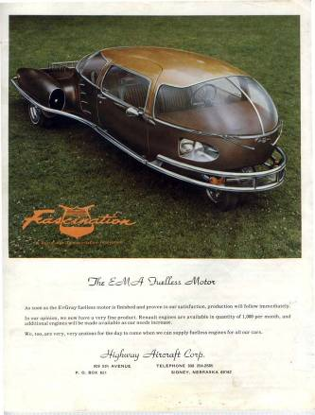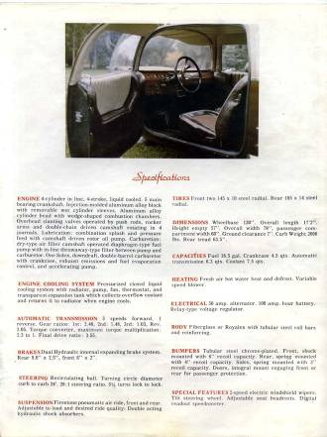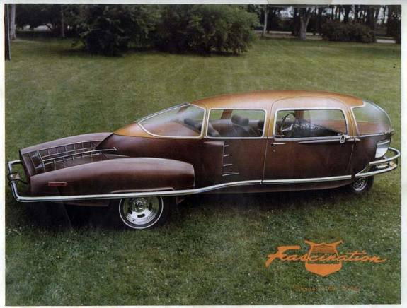

Dear James,

Here is a newly recovered piece of historical information that was just posted by Gary Bedini to the Tom Bearden site. This is the car that the 1973 fueless Motor your father made was suppose to go into. If you have any knowledge about what happened to this venture with Mr. Paul Lewis and the Fascination car I sure would like to add it to our collected history.

The last photo is my latest efforts with bench top experiments. This month's theory is that to build a Free Energy Machine you need to start with a very dead car battery. How is that for thinking out of the box? A research friend of mine in Australia claims that the circuit under constructions cools its capacitors by 3 degrees while operating. If this proves reproducible then we may finally have some experimental evidence of "Cold Electricity".

Have a restful Easter.

Mark McKay

Sat 4/7/2007 8:43 AM

Where can I view the article on the Australia "Cold-Electricity" experiment?

Also, the Lewis' car of '73, was it an "egg" shaped, three-wheeler?
If not, do you have a picture of it? Either way, I 'd love to have
a picture of the Lewis auto!

Dr. James A. Gray, Sr.
"Prayerful Solutions!"
Christian Counseling Services
1335 North Caddy Lane
Wichita, Kansas 67212
(316) 641-7029 (c)
(316) 721-5104 (h)

From: Dr. James A. Gray, Sr. [mailto:icyams@sbcglobal.net]
Sent: Tuesday, April 17, 2007 9:09 PM
To: Mckay, Mark
Subject: Re: Still Working on the EV Gray Saga
Hi Mark,

Indeed I've turned my P/C inside-out affording to locate my work! O' well!
I'll just have to sit back down, re-read your material and rethink my responses for you!
The vanishing SAGA is reminiscent of the old "Twilight Zone" show of the 60s! POOF!

Your humor is well timed and appreciated! I've had a very hard past week and a half!

The Fascination pictures all came through wonderfully, and YES, I recall this automobile
and it's owner. That is to say, I remember my father fusssing about this fellow attempting
to commandeer control of the EMA motor! But at the onset, Dad was excited over the
possibilities of a mutual resolve . . . a resolve which never came to fruition!

As to the "Time-Line" which I wrote for you, please send me a copy of it. Reason? To run
it against some new notes I've found. Some of which were noted in your "lost" manuscript!
Not to worry though, I'll get back to another rewrite/additions soon.

Sincerely, Your friend . . . James

From: Mckay, Mark
To: Dr. James A. Gray, Sr.
Sent: Wednesday, April 18, 2007 10:29 AM
Subject: RE: Still Working on the EV Gray Saga

Dear James,

Here it the timeline you sent me. I must admit I was amiss when writing the "Evolution" condensed history. Some of my dates are way off as you have probably noticed. I was working from memory on a different machine. Any additional information about your father's technical interests prior to 1969 would be helpful in understanding "What happened". If you have some theories of your own be sure and add them as they are probably more valid than my speculations.

Thanks again for all the effort to document this important history.

Mark

Wed 4/18/2007 10:44 AM

Dear Mark,

It is my privilege and honor to assist as you endeavor to write in honesty and accuracy
regarding my father's life and accomplishments . . . good, bad and/or indifferent.

Sometimes truth is greater, or at least more interesting than fiction! Thus, this man
Edwin Vincent Gray: defender of his country, husband, father, provider (greatly so),
socialite and inventor! And so, I'll return to aiding with what I am able, while always hoping
that somewhere someone may be able to reconnect-the-dots of Dada's mind and works to
give to the world a product which will revolutionize the technology of humanity on every
scientific front!

Thanks for remitting the original "Timeline", I'll compare it to my notes as I rewrite.

Sincerely,

Dr. James A. Gray, Sr.
"Prayerful Solutions!"
Christian Counseling Services
1335 North Caddy Lane
Wichita, Kansas 67212
(316) 641-7029

From: Mckay, Mark
To: Dr. James A. Gray, Sr.
Sent: Monday, April 23, 2007 6:36 PM
Subject: EV Gray New Video recovered 1986

Dear James,

I have just received a 1986 Video that shows your father when he was 60 demonstrating his equipment at that time. It is in color, of marginal quality but something different.
Apparently your father also had a Patent In the UK. I haven't been able to watch the whole tape since I'm at work but will concentrate on it at home this evening.
I shall make copies and forward you some in DVD format in a few weeks. Would your other family members want copies as well? Perhaps I should see the whole tape first, but the first 7 minutes looked very interesting.

Mark

Hi Mark,

In all sincerity, I believe they may all enjoy having a copy (1st family)!
Patrick, April and adopted brother have everything they need (supposedly)!
However, if you'll send me one for each, I'll pass them on.
I'll check with them over the next few days to be certain!

Dr. James A. Gray, Sr.

From: Mckay, Mark
To: Dr. James A. Gray, Sr.
Sent: Friday, April 27, 2007 3:33 PM
Subject: RE: EV Gray New Video recovered 1986

Dear James,

Here are some additional shots of your father. There are some other young men in the one photo. Do you recognize anybody, family perhaps?

Mark

Dear Mark,

Yes, I do know the identity of the two young men in the pictures!

The tall, dark haired fellow is my youngest brother Mark (6th born, 4th son of 1st family)!

The shorter, blond haired young man is Patrick (1st born, only son of the 2nd family)!

Interestingly enough, I've always said Mark knows more than he's been sharing, and as always, Patrick has, and continues to know more about Dad's works than the 1st family!

However, Patrick was quite young in these pictures, approximately 18-19, while Mark
was approximately 28-30 in age. I need to know dating of the video tape to be certain.

I was never aware of these two cordially worked together with our father on his enterprises!

Well, you live, and, you learn! Can I get an Amen on this?! LOL! Dr. James A. Gray, Sr.

From: Mckay, Mark
To: Dr. James A. Gray, Sr.
Sent: Friday, April 27, 2007 6:33 PM
Subject: RE: EV Gray New Video recovered 1986

Dear James,

The date on the Tape is 1-18-86,

There is also as news clip about the first Shuttle disaster, where it blew up just after take off. So in that time frame.

Maybe you can send him these photos and see if it jogs his memory a little. To be that close to the equipment he must know something about its history.

The older man identified himself as Joe Gordon, whom I have spoken with on the phone. He is in Texas. I need to talk to him some more and get more details on events in the 86 to 89 time frame. Looks like a lot was going on then.

Mark
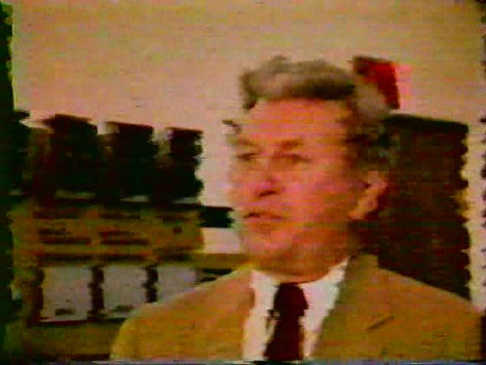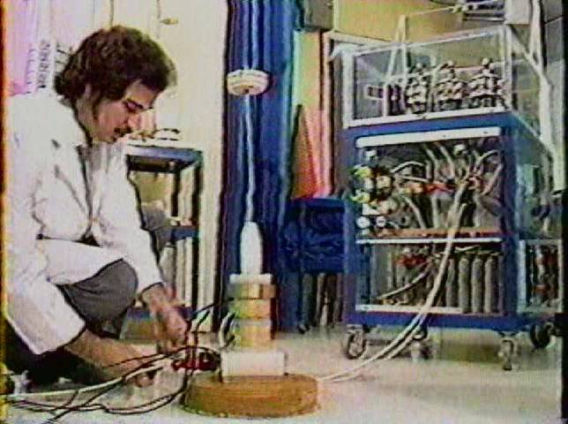

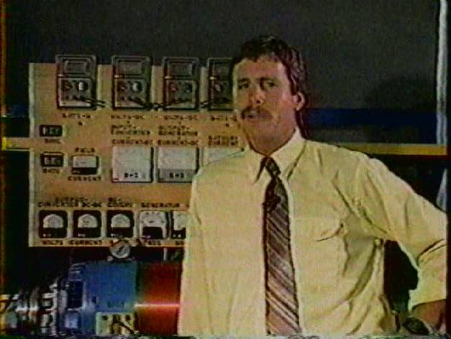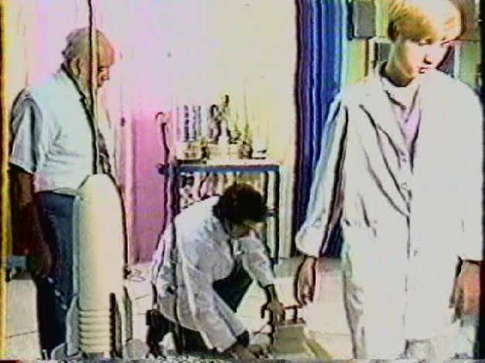
Fri 4/27/2007 6:41 PM

Thanks for the pictures; however, their clarity is quite poor!
Seems as though they are too large, too expanded!

I believe Joe Gordon is the man in the rear of picture #3, I'm just not sure!
Then again, it he may be the one in frame #2! I'll send them to Mark to see
if he can identify either of them!
Dr. James A. Gray, Sr.
Fri 5/4/2007 1:21 PM

Hi Mark,

Just a note to say I "received" the six (6) disks (6), and I'll review one
as quickly as possible.

Also, I will rewrite my last response and, my review of the current disk too!

Sincerely . . . James

Dr. James A. Gray, Sr.
"Prayerful Solutions!"
Christian Counseling Services
1335 North Caddy Lane
Wichita, Kansas 67212
(316) 641-7029 (c)
(316) 721-5104 (h)

Fri 5/11/2007 6:25 PM

Dear Friends in Christ Jesus,

Today I saw my 2nd orthopedic surgeon for another view on my right hip problem!

It twas neither enjoyable or encouraging. My hip is under serious deterioration
from both 15 years of wear and the fall I took at the end of February.

I've been instructed to walk about only when truly needed to until surgery.
Not only is the pelvic socket damaged, there is degeneration at the top of
my femur and the surrounding tissues (the medical term was about 3 1/2 pages long)!
This can undermine the strength, support and integrity of the prosthesis.

Now what to pray for:
1- I have to pick one of two surgeons who are in agreement of the
situation. PTL!
2- I also have to select one of two dates (June 7th or 14th) set for surgery
very soon!
3- Please Pray For God's Choice Of Surgeon For My Situation And . . .
that no more damage will take place my right hip region until then!
4- Also, pray for a good surgery outcome, and no anesthetic problems
due to the dangers of arthritic deteriation of my upper-spine (neck).

*I know that He will take care of me . . . He always does! Hallelujah!
Nonetheless, my human side always makes me apprehensive, pray for my
peace of heart! This will be my "11th" major orthopedic surgery. It always
beats the alternative!

When I was 14 1/2, I promised God that as long as He continues to keeps
me upright and mobile, and continues to grant me good health, I will serve Him!
And I WILL ! Amen!

Mon 5/21/2007 3:34 PM

Final CONFIRMATION:

Today's final consultation with Dr. Kris Lewenowski regarding my right hip surgery,
confirms what I believe to be God's selection! To be on June 7th, 7:300 am. at
Via Christi Regional Medical Center.

My hip may well constitute a "rebuilding" of my right pelvic skeletal-section before
the joint can be replaced! The final decision will be made at the time of surgery.
This would mean attaching a steel box to that region of my skeleton which would
receive the new hip-joint! Please pray that the additional 2lbs will not be rejected
by my body.

My God has always been with me . . . and I'm banking on His healing grace again! PTL!

Incidentally, my surgeon says I am rapidly becoming a "celebrity"! This is due to:
1- the fact that I have had rheumatoid-arthritis for 58 1/2 years, and my health has been
sooooo blessed by our Heavenly Father,
2- I'll be carrying in the neighborhood of 18 lbs of steel from there on! (I figure I'll be able
to set off the airport security system from the parking-lot!) LOL !

Sincerely, Your friend in Christ Jesus . . .

Dr. James A. Gray, Sr.
"Prayerful Solutions!"
Christian Counseling Services
1335 North Caddy Lane
Wichita, Kansas 67212
(316) 641-7029 (c)
(316) 721-5104 (h)

From: Mckay, Mark
To: Dr. James A. Gray, Sr.
Sent: Tuesday, July 17, 2007 7:32 PM
Subject: Research update

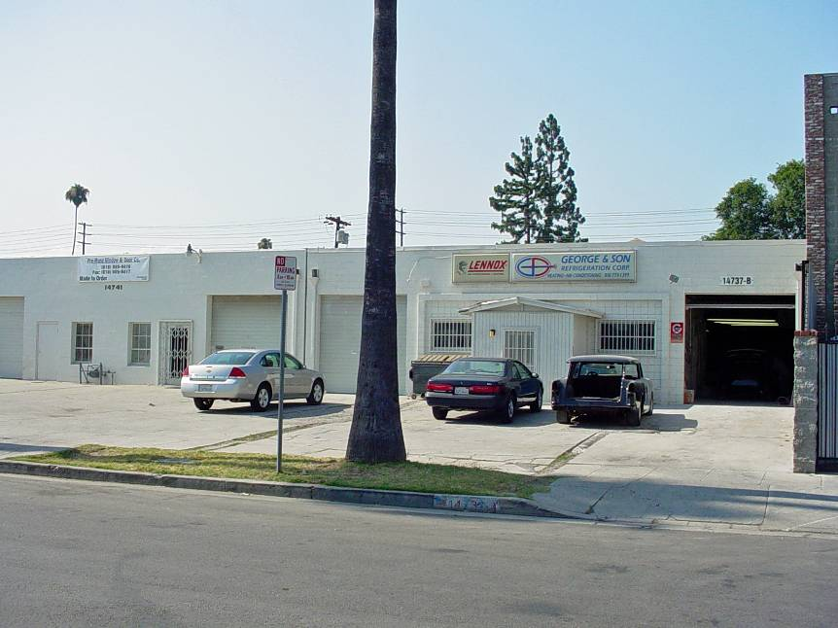
Dear James,
A short note to let you know that I took a trip to Van Nuys, and Palmdale, CA. My main purpose was to visit Nelson Schlaff, your fathers technician from 1981 to 1982. In the process I drove by 14737 Calvert Street to photograph the building where it all started. Your cousin George Gray was there and I talked to him for a few moments. He also showed me a number of interesting photos from January 1973 where a Japanese group was signing a letter of intent. Apparently, the deal fell through. George claims that Marvin Cole, in his opinion, was the source of the technology. I called him when I got back to Spokane. He said he "didn't want to get involved". So much for that source. It seems that George mentioned that he owed your father a great deal of gratitude. I can certainly understand his position and respect his wishes.
My two day discussion with Nelson Schlaff (age 66) reveled that your father withdrew his technology from 1979 to 1987 for unknown reasons. Nelson's job was to get the motors and "popping coils" to operate on classical electricity. It eventually took 5 times as much energy to do the same things they did in the 70's. It seems that your father built one and only one CSET in 1986. It appears that this was the last non-classical converter ever constructed. Your brother Mark claims that he heard a rumor that the technology was sold in 1979. He doesn't know to whom.
Nelson reports that he went to work for Mr. Russell Audrey of Dodge City Kansas after your father's death. When he was there he reported that several of the motors, the "Trigger-Cart", and a huge portion of the spare parts were in the shop that he worked in. This is where the last surviving motors were discovered in 2000. I have a few phone numbers and I'm following up on finding out what events took place there. The people I have numbers for don't answer their phones very often (if at all).
I hope you are recovering well from your medical procedures.
Mark McKay <<DSC02543.JPG>>

Dear Mark,

I am so grateful for this photograph of my father's (now George's) business building!

It's the first I've seen it since 1970-71 . . . I was overwhelmed to tears for some reason!

I know tis a lot ask of you, but if possible, could you send me a copy of your original
so that I may frame it and place it in my office? Your picture has a flurry of memories
and emotions running through my heart and mind! Most are very sweet, some unfortunately
bitter! But all-in-all, they are worth revisiting!

Again, thank you so much for sharing your efforts!

Mark, tomorrow I'll respond to this letter . . .

Sincerely,

Dr. James A. Gray, Sr.
"Prayerful Solutions!"
Christian Counseling Services
1335 North Caddy Lane
Wichita, Kansas 67212
(316) 641-7029 (c)
(316) 721-5104 (h)

Fri 7/20/2007 12:27 PM

Hi Mark,

Just a heads-up on a Mr. Gary Vesperman from Henderson, Nevada.

He has an honest interest in knowing technical info regarding my father,
his invention(s), etc.

He is also the Co-Owner and Director of Research for the Blue Energy
Corporation plant located in Henderson, Nevada. His e-mail address
is: www.blue-energy.us

I believe you and he may be able to help eachother . . . it's your call.

It appears that he has tremendous background in an area you've
questioned me about, but I couldn't meet your needs on the intellectual
and technical level.

Anyway, I've shared with him your e-mail address so you two can decide
the depth of assistance one can be to the other!

I hope you are not offended and/or upset with my decision, its just that I
felt it would be best for you to talk rather than for me to be a "go-between"
with my lack of effective knowledge in what he would like to know and
accomplish.

Sincerely submitted for your edification and consideration,

Your friend . . . James (God-Bless-You)

Dr. James A. Gray, Sr.
"Prayerful Solutions!"
Christian Counseling Services
1335 North Caddy Lane
Wichita, Kansas 67212
(316) 641-7029 (c)
(316) 721-5104 (h)

From: Gary Vesperman
To: Mark McKay
Cc: Dr. James A. Gray Jr.
Sent: Tuesday, July 24, 2007 11:39 PM
Subject: Do we have a genuine suppression case with Ed Gray?

Mark,

Thanks so much for your many comments on the raw draft of my Ed Gray suppression story.

I read over your remarks twice and the timeline once again. I could not find any solid instances of possible suppression. There is this one:

"Gray's problems began last July 22, when L.A. authorities raided his plant in Van Nuys, CA. Virtually everything in the building was confiscated --- including his working prototype motor.

Seven months later, not a single charge has been brought against Gray. Yet, the L.A. District Attorney's office still has his records and engine models.

The Van Nuys raid is only the latest incident in a strange pattern of "non-arrests" of automotive inventors that dates back more than half a century."

But Nelson claimed that much of it was returned to Gray except the 9-pole motor.

I suppose I could write a half-page story around that incident, and let readers dig for themselves the whole messy story. You know far more than I do. Is this one incident a genuine suppression case? Or is it just an overworked DA office stumbling along? The LA DA's certainly weren't concerned about conservation, environmental protection, etc.

Gary Vesperman

Wed 7/25/2007 10:07 PM

Dear Gary & Mark,

Here's some irony regarding your piece below!

Two years ago a very special friend of mine died of esophageal-cancer, his name was Rev. Eugene Moreland. This wonderful human-being was the Pastor of the College Hill Baptist Church located on the north end of San Bernardino, California. It was his message on John 3:16 that made me realize I needed Jesus in my life! In fact, it was the second Sunday of hearing his powerful Tulsa, Oklahoma styled preaching that brought me to my knees before God!

Immediately, my wife and I joined this lil' church, and in so doing we met his wife and children. I was in my mid twenties, his children were 4-5 year before me (near 30). They were a good family. One of the children was a fellow by the name of Mike. Mike worked for the Riverside, California police department, he was in his early years as a policeman.

Let me move ahead just a bit. Pastor Moreland, Mike's father, on a visit just prior to going home, shared with me a fabulous story of a man who had this wonderful invention! He was so captivated by this machine that he and hundreds of other Southern Baptist ministers unloaded millions of their hard earned retirement accounts for stock in this exciting invention! This was done back in the early to mid 70's in the states of California, Idaho, Arizona, Colorado, Nebraska, Kansas, Missouri, Arkansas, Iowa and many other interior states! In the Dodge City area of Kansas one church alone purchased 1.5 million dollars into Zetex and Zemex stock.

Now here's the irony of this story. I knew nothing of these folks business venture with this man and his invention until 33 years later, in my home here in Wichita, Kansas! Furthermore, Pastor Moreland and I had never connected the fact that this man of promises of untold wealth was . . . my father! I'm not finished yet! The arresting detective of the Riverside, California police department was my friend, and Pastor Moreland's son . . . Mike Moreland! It appeared that Mike's attempt to disrupt my fathers plans caused quite a rift in this family unit! You see, this sincere father and man-of-God saw the potential in my father, while his son was being influenced by unknown subjects to squash the "EMA" program and render my father a fraud! But he failed, my father was legitimate after all!

This story has never been told before simply because I hesitate to corrupt anyone person's image, after all, there is almost always two sides to every story/event, etc! Each of these men were/are good men, but with different perspectives!

Sincerely, James . . .

Dr. James A. Gray, Sr.

From: Gary Vesperman
To: Dr. James A. Gray Jr.
Cc: Mark McKay
Sent: Thursday, July 26, 2007 9:09 PM
Subject: Call Mike Moreland?

Jim,

I have a couple of dandy small-world stories myself.

Maybe you should call Mike Moreland and ask him if knows whether the SEC actions regarding your father were arranged by secret US Government energy invention suppression bullies.

Gary Vesperman

Gary,

I already know the answer to your question.

The attack upon my father and his invention were spurred by local politicians
jockeying for favor and higher position, and further exasperated by lobbyist and
FBI agents who were basically carrying out the wishes of scorned big oil entities
of that area: Union 76, Standard & Mobile! Mike, in my opinion was bucking
for deeper roots in law enforcement. Though I continue to communicate with
Evie Moreland (Gene's wife), and Mike's mother, He I have not communicated
since that time frame. As a final thought, I have attempted reacquaintance with
the Moreland siblings, but to no avail! I quess they take a bit of stock in the
axiom: "The apple doesn't fall far from the tree." In essence, it's fair game to
assume that an offspring of Edwin Gray's isn't worthy of further association
because of the great loss of their parents life-savings! Personally, I can understand
this, I know how difficult is to raise a family on a local Pastor's salary! Too many
folks feel don't realize that these men live by faith . . . they are not TV evangelists!

However, after an 1 1/2 hour lunch and power nap, it has come to me to speak with
Evie Moreland, and see what she can tell me about her son's motivation for attempting
sensure my father's efforts. I make no promises, if I'm able to secure any worthwhile
information . . . well, I'll share with you and Mark Mckay!

Sincerely,

Dr. James A. Gray, Sr.
"Prayerful Solutions!"
Christian Counseling Services
1335 North Caddy Lane
Wichita, Kansas 67212
(316) 641-7029 (c)
(316) 721-5104 (h)

From: Mckay, Mark
To: Dr. James A. Gray, Sr.
Sent: Friday, May 25, 2007 7:05 PM
Subject: RE: Surgery Confirmation!

Dear James,

Attached is a first cut of a two page condensed bio on your father that I would like you to review when health and time permit. This will be posted on Dr. Lindemann's remodeled web site in the near future. It contains all the major events that you and your brother Mark have shared with me. I hope It will be an improvement over what was available before.

I would like to add your mothers maiden name, but I couldn't find it.

I hope your are in good sprits and have an effective plan to deal with your condition.

Sincerely,

Mark McKay

Thu 8/23/2007 1:29 PM

Hi Mark,

I am now in the process of sorting through a 35 business letter back-logue!
This is among them. I'm not certain to whether I responded to your query
regarding my mother's maiden name, nonetheless, here it is: Her "maiden"
name was/is "Curry", which had been reduced from it's original after her
father's parents were granted citizenship! Originally it was "O'Curry."

James . . .

Mon 1/7/2008 10:17 AM

Please pray for TUESDAY, it will be my day for all testing!

*PRAY especially in the affirmative for a GOOD REPORT on the C/T scans!

I am claiming the following two Scriptures form God's Holy Word for tomorrow
for the best results! Amen! The 1st speaks of "believing" in Jesus when He said:
"I tell you that if two of you on earth agree about anything you ask
for, it will be done for you by my Father in Heaven" (Matthew 18:19).

The 2nd speaks of the "faithful", to act by bringing their sick to Him . . . they will be healed:
"Jesus went throughout Galilee, teaching and preaching the good news of the Kingdom,
and healing every disease and sickness among the people . . . and the people brought
to Him all that were ill with various diseases . . . And He Healed Them (all of them)"!

Rejoice with me that God will bless all my results! PTL!

Dr. James A. Gray, Sr.

Dear Friends/Family,

Well we just came home, and I'm trying to get refocused!
Dr Johnson (Oncologist) spent quite a bit of time with us
detailing where I am, etc! As he revisited the results from
the past two weeks of labs and scans, he seemed puzzled.
He told us something didn't seem right. He went on to say
that the C/scan and Pet/scan didn't agree with former data
from the surgeon!

It didn't dawn on us till later that all the latest data says there
is NO cancer anywhere else in my body, with the exception the
lower esophagus and general area nodes! Why does this sound
odd? Because the surgeon told my family and friends that he
closed me up because he saw cancer "all over my interior"!
Again, the high-dosed C/S and the radioactive P/S showed
absolutely no other source of cancer incidents from my pelvic
to the top of my brain! You Take It from There! God Is So Good!

Also, the surgeon so noted treatment would be futile! Giving me
2-4 months on Earth! Not SO!
After Dr Johnson and two radiologists read, and re-read the scans,
they could not, did not find any further indicators! All my cancer
is contained in a general area! Also, they WILL be able to reach
the nodes between the pancreas and abdomen with radiation!
Though i am in stage 3 of 5, my prognosis for recovery is much higher!

Oh, one more thing, I start Chemo next Monday at 9am and I'll
be there all day. At the end of the day they will connect my
new metering pump. It'll will stay on me 24/5 (Mon-Fri)! On Friday I'll
return to the center for removal and blood-work. Then, I'm off for
two weeks! After that, we repeat the cycle for two more terms
(1-on, 2-off)! Then more labs and re-run the C/S and P/S again to
see how well things are going! If need be, this program can be
repeated 3 times! Dr Johnson doesn't feel the need will arise!
As always, all matters of life are in His hands and for His glory!

Dr. Johnson feels much stronger of the prognosis now! Keep praying!
Your prayers are powerful! Amen!

New Prayer Request: Pray that my system tolerates the powerful meds
I must now endure beginning Monday at 9am!

Always in Christ,

James . . . . . . .

Dr. James A. Gray, Sr.
"Prayerful Solutions!"
Christian Counseling Services
1335 North Caddy Lane
Wichita, Kansas 67212
(316) 641-7029 (c)

This was the last email I received from James. I didn’t bother him with additional requests for information. I figured when he recovered and was feeling better he would again contact me. That event never happened.

Later, I learned from his wife that he passed away in 2009.

I am truly grateful for the brief time and conversation I was able to share with James. His honest disclosures helped establish the truth behind this interesting adventure and better sort out the few honest facts from the plethora of fictions.

Without Dr. Gray’s guidance I would have never been able to proceed with this technical research.

Mark McKay

